- USER CASE DIAGRAM.

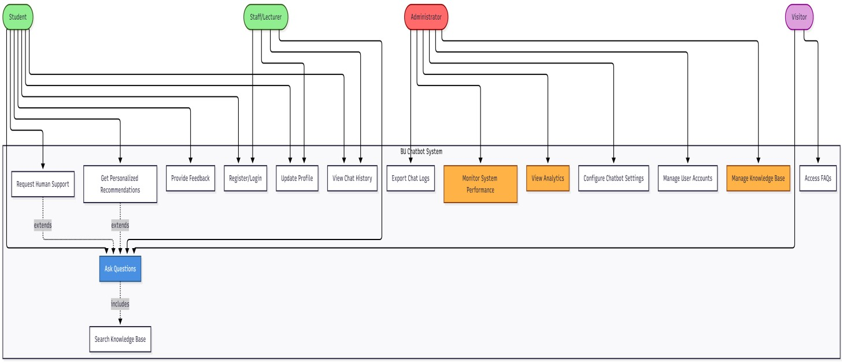

- SYSTEM ARCHITECTURE DIAGRAM

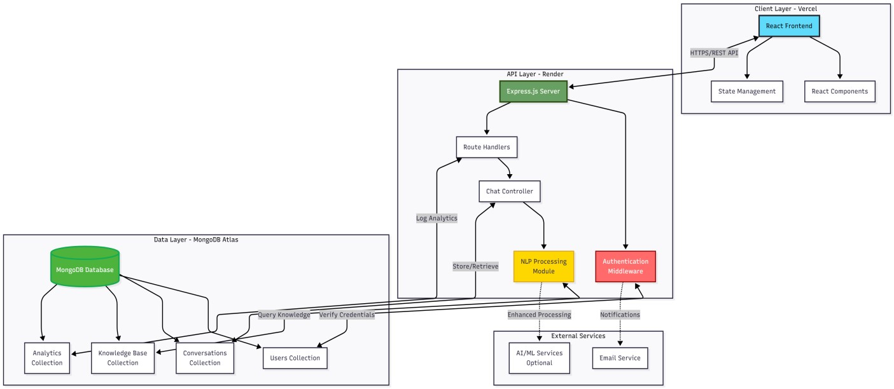

- CONTEXT DIAGRAM

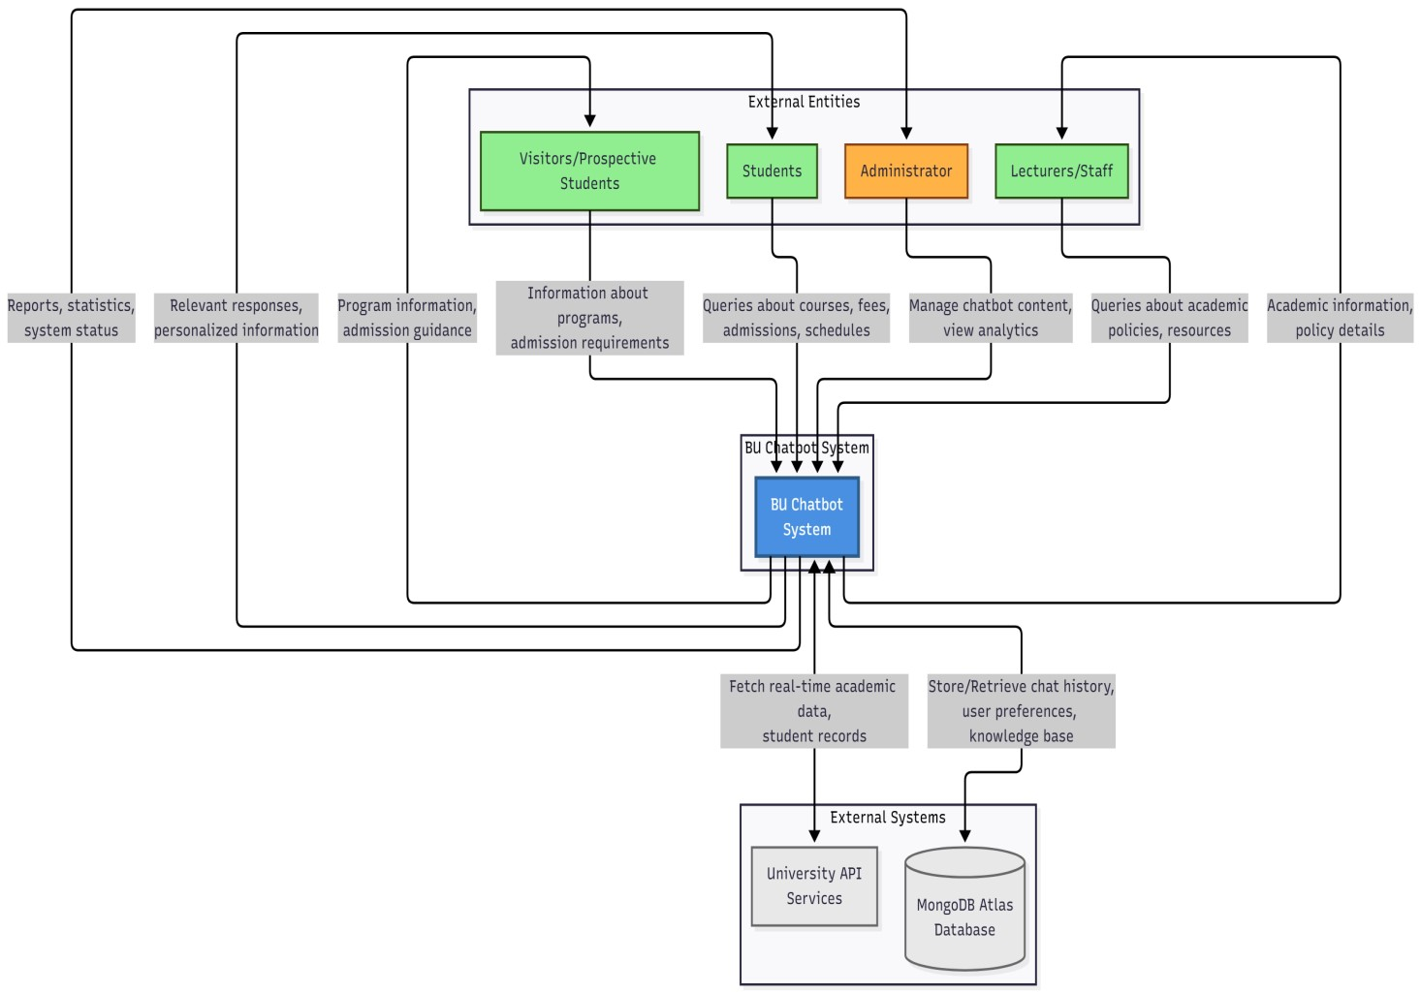

- DATA FLOW DIAGRAM – LEVEL 0

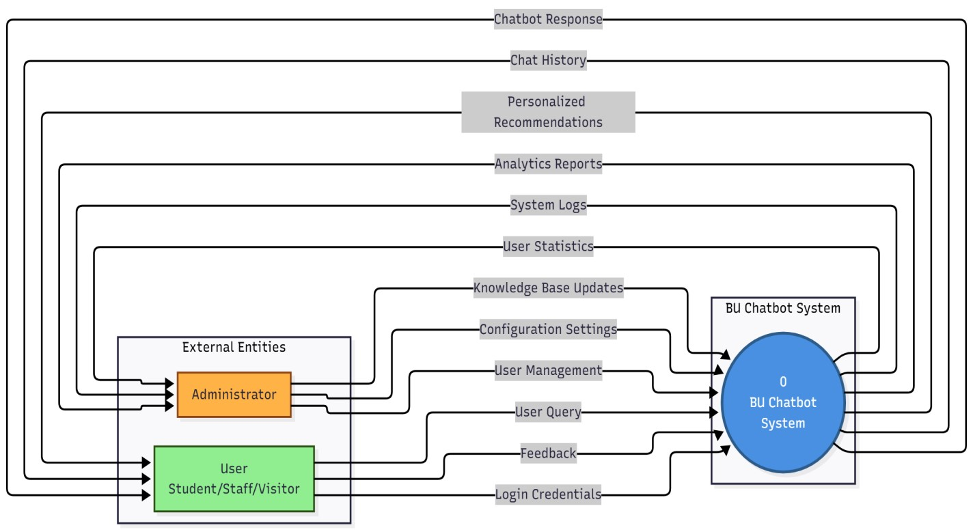

- DATA FLOW DIAGRAM – LEVEL 1

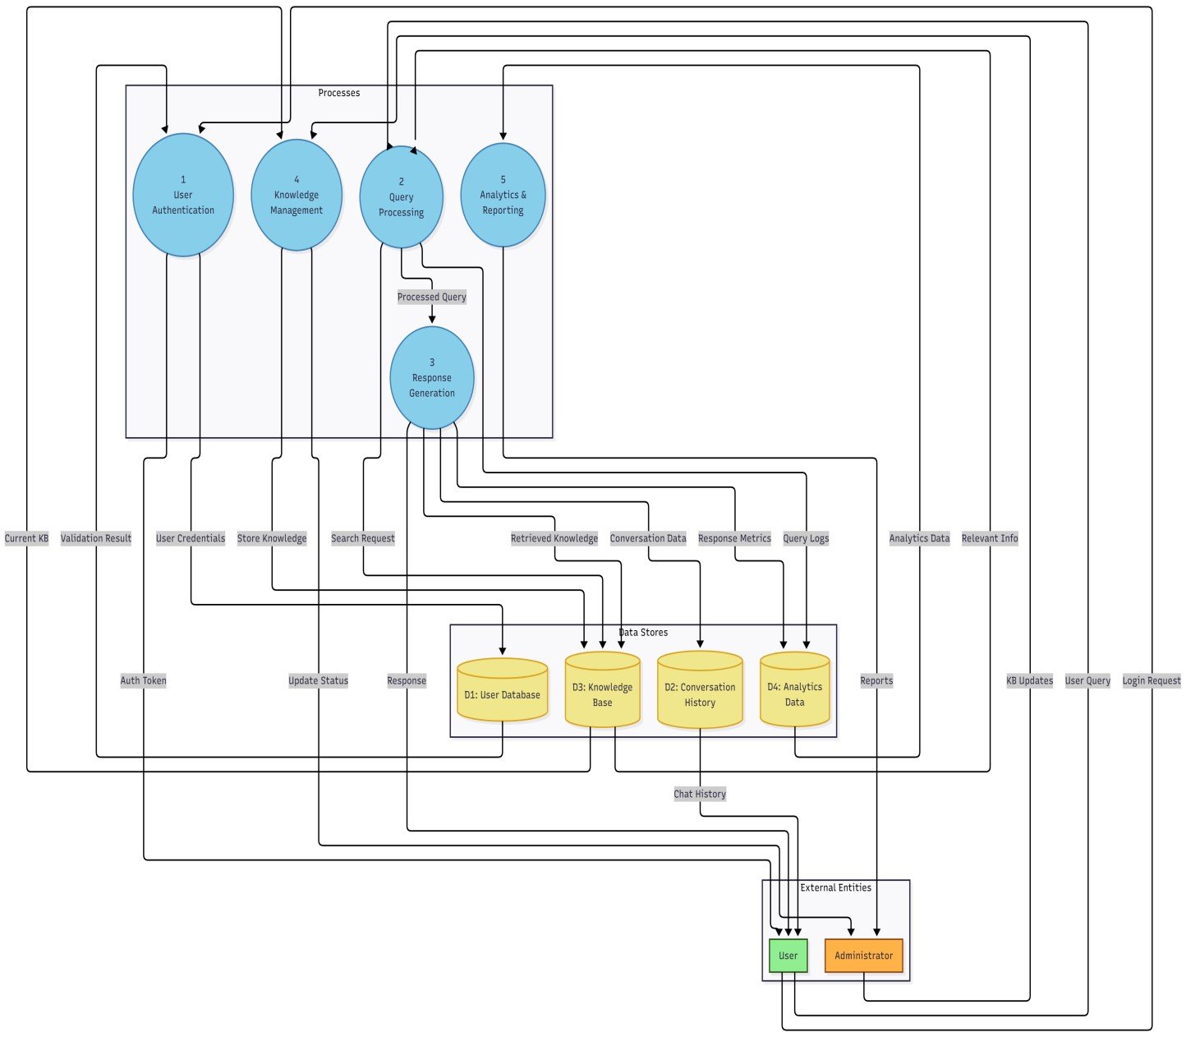

- ENTITY RELATIONSHIP DIAGRAM
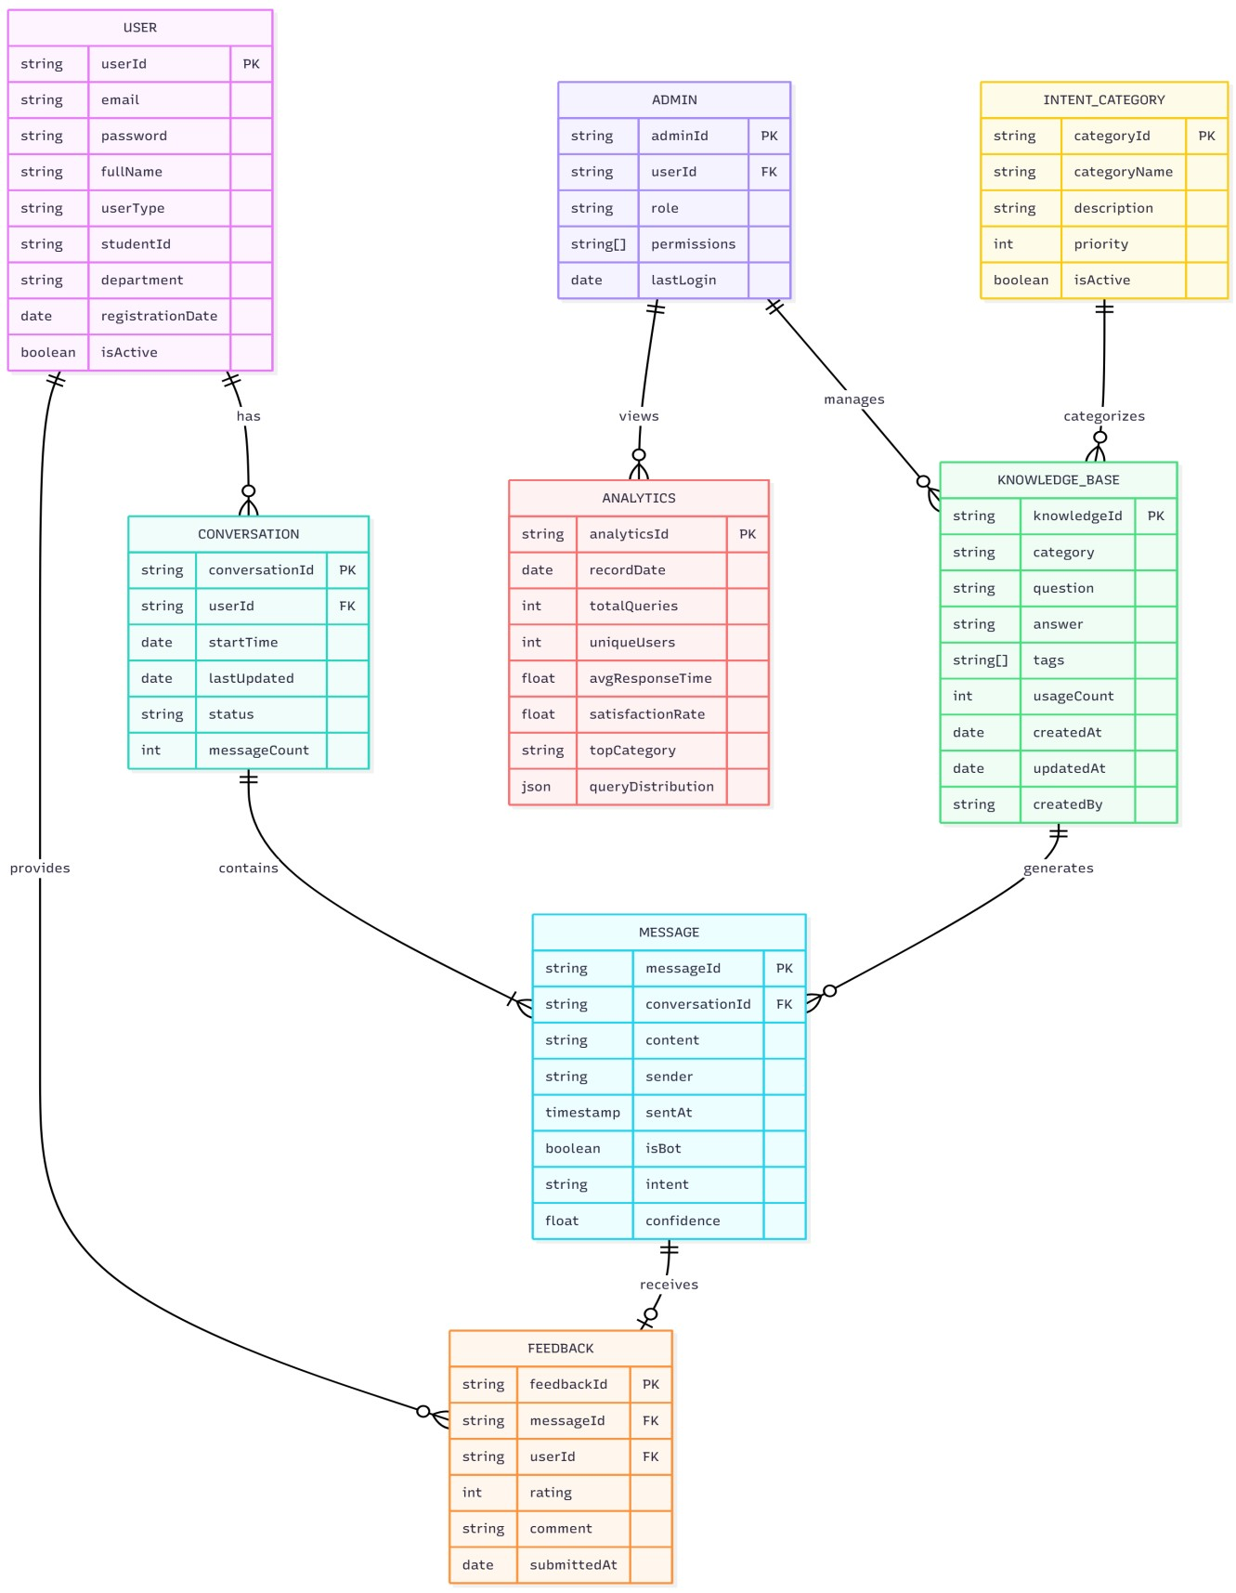
- SEQUENCE (QUERY PROCESSING) DIAGRAM

